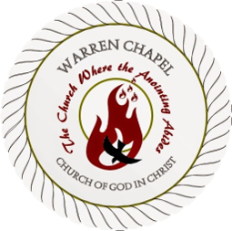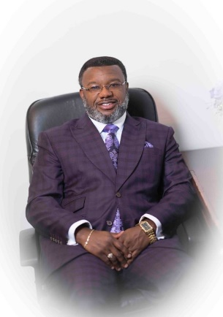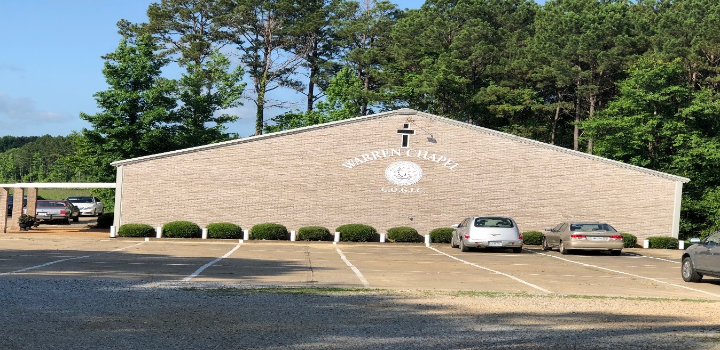

Warren Chapel Church Of God In Christ

**300 Pond Avenue | Louisville, MS 39339 |(662) 779-0038 |Warrenchapel315@gmail.com**

**MINISTRY EVENT**

*Speaker: Dr. Marcus J. Smith, Sr.*

Greetings,

We are looking forward to the upcoming event with you and are expecting a mighty outpouring of the Spirit!

This information provides us as a ministry what is necessary in order for the services to have the greatest possible impact for you & your congregation. If there is any additional information you need or if you have any questions concerning any of the areas described, please contact Dr. Marcus J. Smith, Sr. Administrative Team at (662) 803-3685 or (601) 500-2329.

Blessings,

Dr. Marcus J. Smith, Sr.

Dr. Marcus J. Smith, Sr**.**

[warrenchapel315@gmail.com](mailto:warrenchapel315@gmail.com)

www.warrenchapelcogic.com

“The Church Where The Anointing Abides”

